Incident Investigation Report HSE-INC-2026-018
Dropped object near miss on MV Sea Atlas, 3 June 2026
Hannah Weber · 12 June 2026 · HSE-INC-2026-018
Field | Details
Incident no. | HSE-INC-2026-018
Date / time | 3 June 2026, 10:47
Location | Main deck, MV Sea Atlas, at HB-A08
Classification | Near miss – high potential (dropped object)
Injuries | None
Investigation lead | Yusuf Demir (Weyland) with Atlas Marine HSE Manager
Report approved | Hannah Weber, 19 June 2026

1. Summary
During rigging for the lift of the transition piece for HB-A08, a shackle pin (2.8 kg) fell approximately 18 m from the crane block onto the main deck. It landed 3 m from a deck crew member who was outside the marked drop zone. Nobody was injured. Using the DROPS calculator, a 2.8 kg object falling 18 m is in the fatal category. The event was therefore classified as a high-potential near miss.
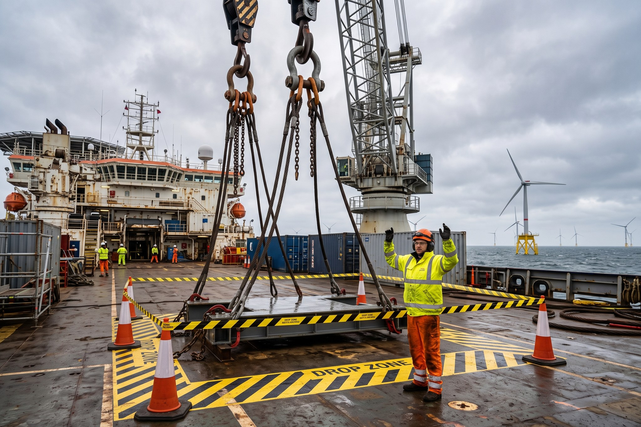
Rigging area on the main deck of MV Sea Atlas (reconstruction after the event)

2. Sequence of events

3. Root cause analysis
Preliminary finding: missing split pin on a bow shackle. ICAM workshop scheduled for 15 June.

4. Immediate actions
- All shackles quarantined and inspected
- Lifting resumed after 34 h stand-down

